1. Insert 3 new records into a 'playlist' table for a music app, each with playlist_id, user_id, playlist_name, and created_at fields.
Ans:
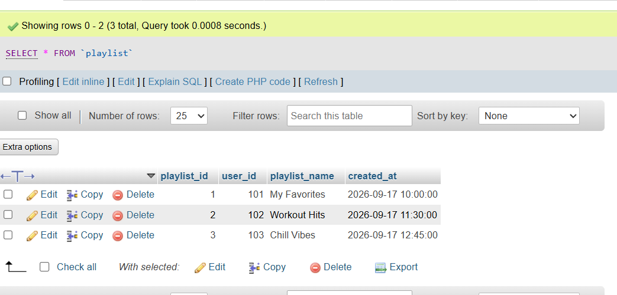
2. Update the email and phone number for a user in the 'user_profile' table where the username is 'foodielover' (simulate a Zomato-style profile edit).
Ans:
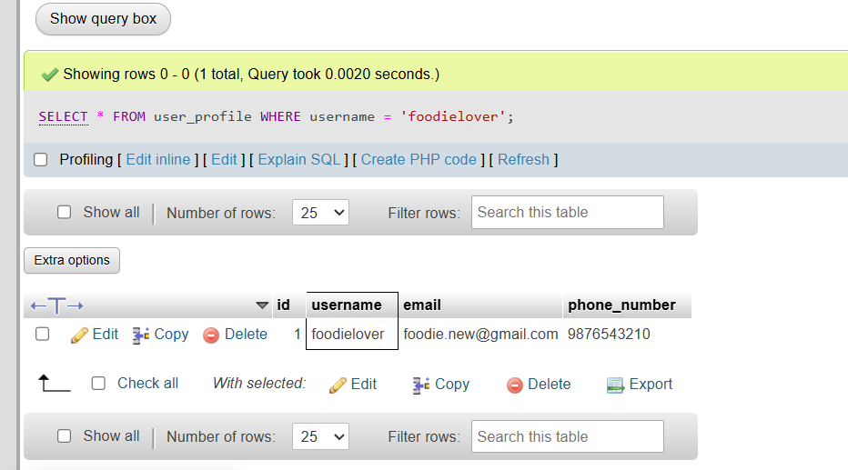
3. Delete all records from a 'sessions' table where the expiry_time is earlier than the current timestamp, simulating expired login sessions like in Paytm or Flipkart.
Ans:
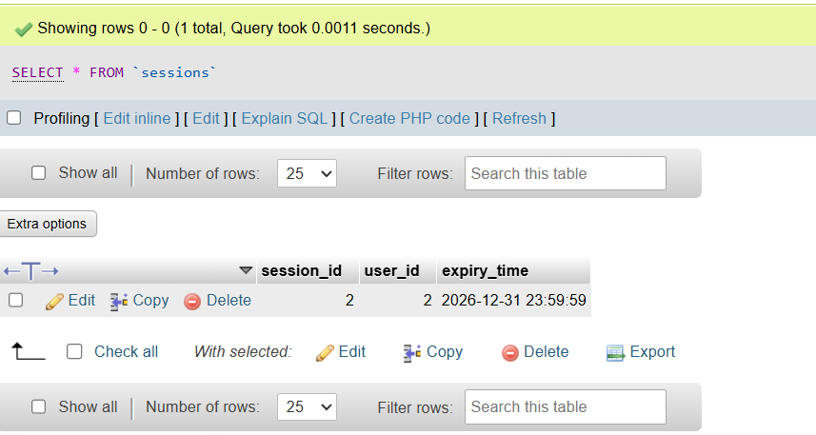

4. Insert test data into a 'login_attempts' table for 2 different users, including fields for user_id, attempt_time, and status (success/failure), to prepare for login module testing.<br><br><em><strong>Hint:</strong> Use different timestamps and both success and failure statuses for variety.</em>
Ans:
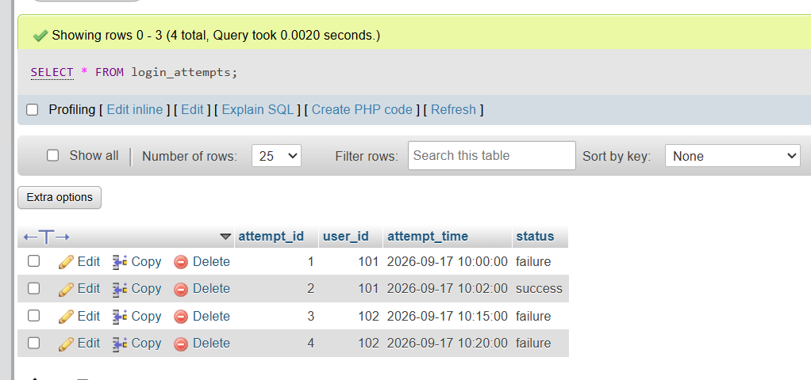

5. Update the 'playlist_name' in the 'playlist' table for a specific playlist_id, then verify the change by selecting the updated row.<br><br><em><strong>Constraint:</strong> Perform both the UPDATE and SELECT statements and check the result.</em>
ANS
